



OT Workshop

Building Skills for Independence

Workbook – Session 1

**Please complete the below exercise prior to the first session.**

This workbook contains activities which use everyday tasks to help us to explain and demonstrate the concepts as part of the OT Workshop.

Some of these activities may not relate to your child’s needs - we ***do not*** expect your child to be able to do these specific tasks and we recognise your child may be quite different from the examples provided throughout this workshop in terms of their age and skill level.

The examples presented in this workbook and workshop are for the purpose of creating discussion and to help you apply the thinking to your own child.

Session 1

We would like to introduce a way of thinking which we will use throughout the workshops. This is called the “Person, Environment, Occupation and Supporting Adult mode” (PEOS). We will explain this to you in more detail in the first session.

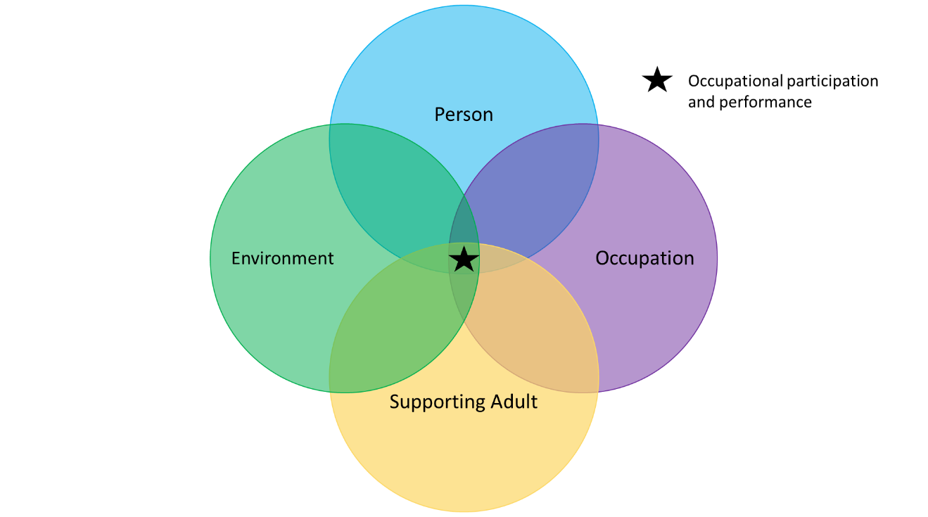

To practice using the model we would like for you to watch a **video** prior to the first session. We will use this video to guide our discussion in the workshop. Please see your email for more information.

While you are watching the video, we would like you to think about the following P, E, O and S

* The **Person (P):** 
  + Age of the child?
  + What parts of their body do they need to use for the task?
  + Level of calmness?
  + Level of focus?
  + Does the child want to do the task?
  + Do they understand the task?
* The **Environment (E):** 
  + Where is the task being completed?
  + What is in the surroundings?
  + Noise and sounds
  + Lighting
  + Temperature
  + Other people in the environment.
* The **Occupation (O - task):** 
  + What is the task?
  + What items/tools/equipment are used for the task?
  + Does the child know the steps?
  + How long does the task take?
  + What time of day is the task completed?
* The **Supporting Adult (S):**
  + What is the adult helping the child do?
  + How does the adult support the child?
  + How much support does the adult give the child?

There are PEOS circles on the next page if you would like to write notes while watching the video.

You do not need to submit any notes you take.   
We look forward to seeing you at Workshop 1.

**Occupation**

**Person**

**Supporting Adult**

**Environment**

IMPORTANT for the workshop:

1. If you:

* cannot make the workshop
* are not able to access the virtual link

**Please contact 0203 049 8181 or 07598 552 396 to cancel your attendance at the workshop – Please leave your name, child’s name, child’s DOB and NHS number when you call.** If you do not attend the workshop and do not give prior warning, your child will discharged from the service.

If you are required to cancel your first session you will be placed back onto the waitlist for workshops. If you are unable to attend the third offer of workshops then you may be discharged.

1. If you are late by 20 minutes or more, you will be asked to contact **0203 049 8181 or 07598 552 396** to re-book within 2 weeks, we will not be able to accept you into the workshop.
2. The workshop will likely run for 1-1.5hours so please allocate enough time to complete the workshop.

For Online Workshop:

1. Online workshop rules: it can be really tricky to have everyone online and try to talk at the same time so here are a few ground rules to make it easier for everyone:
   1. Keep your microphone on mute while you are not talking – this can be done by clicking on the microphone icon.
   2. If you would like to talk, click the microphone icon to un-mute.
   3. Say your name first and then ask or discuss what you would like.
2. Your workshop session may be recorded for training and development.  The recording will only be used internally within the department for the purposes of reviewing the workshop structure and content and will not be shared with any external parties.  Please let us know if you do not wish for your session to be recorded.

We look forward to seeing you in the online workshop you booked into!

Kind regards,

**The Children’s Occupational Therapy Team**