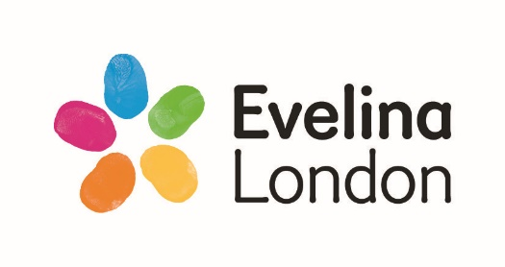



OT Workshop

Building Skills for Independence

PEOS and CPA Forms

The below forms are available for use during the OT Workshop. You will also be able to access these at any point following the workshop.

The Occupational Therapists will direct you how to use these.

© 2017. All rights reserved. Guys and St Thomas NHS Foundation Trust

**Occupation**

**Person**

**Supporting Adult**

**Environment**

**Collaborative performance analysis (CPA) form**

**Parent’s goal:**

**Date:**

**Parent’s name:**

**Child’s name:**

**Parent’s homework:**

What might help?

**What have I tried?**

**What is difficult?**

**What is going well?**

**Please have this with you during your next session**

**EXAMPLE  
Collaborative performance analysis (CPA) form**

**Parent’s goal: To put on a shirt**

**Date:**

**Parent’s name: XXX**

**Child’s name:**

**Parent’s homework:**

What might help?

-Try in front of a mirror

-Use prompt “label at the back”

**What have I tried?**

-Showing them how to do it

-Telling them what to do

**What is difficult?**

-They put it on wrong way around

-They get frustrated when makes mistake

**What is going well?**

-Child is motivated to try

-They can do it sometimes

**Please have this with you during your next session**